Your Paper Title is Times New Roman 14pt Continue on a second line if needed

(Author, Times New Roman 11pt) Name Surname 1, (Coauthor) Name Surname1, and

(Coauthor) Name Surname 3

**1** Affiliation (Times New Roman 10), Street, Number, Area code, City, Country, Email

**2** Affiliation (Times New Roman 10), Street, Number, Area code, City, Country, Email

**3** Affiliation (Times New Roman 10), Street, Number, Area code, City, Country, Email

Abstract (Times New Roman 11, bold)

The Abstract body is written in Times New Roman 10, aligned on both sides and indented 0.5 cm on both sides. The Abstract body is written in Times New Roman 10, aligned on both sides and indented 0.5 cm on both sides. The Abstract body is written in Times New Roman 10, aligned on both sides and indented 0.5 cm on both sides. The Abstract body is written in Times New Roman 10, aligned on both sides and indented 0.5 cm on both sides. The Abstract body is written in Times New Roman 10, aligned on both sides and indented 0.5 cm on both sides.

**Keywords:** Key words are written in Times New Roman 10 (title is in bold).

# Introduction

All section titles are in Times new Roman 11, bolt. Section titles start without indentation. The text is in Times New Roman 10 aligned on both sides. First line of each paragraph indents .5 cm. Leave one line spacing before the subsection title. No extra line spacing after the Section title. Maximum length of the paper is 10 pages. The text is in Times New Roman 10 aligned on both sides. First line of each paragraph indents .5 cm. Leave one line spacing before the subsection title. No extra line spacing after the Section title. The text is in Times New Roman 10 aligned on both sides. First line of each paragraph indents .5 cm. Leave one line spacing before the subsection title.

$Re=\frac{W_{in}d_{h,in}}{ν}$ (1)

and text may continue after the equation without indent.

Equations indent .5 cm. with 6pt spacing above and below. They are numbered in increasing order. Numbers are placed at the right side between brackets. Use SI units. Other units can be placed between bracket after the SI value.

Legend of Tables are written before the table in Times New Roman 9 bold and centered in the column. One line spacing before the legend of the table.

Table 1: Your caption

|  |  |  |  |  |  |
| --- | --- | --- | --- | --- | --- |
|  | *Win*(m/s) | dh,in (m) | rpm | *Re* | *Ro* |
| impeller | *290* | *.0008* | *40 0000* | *15 800* | *0.26* |
| impeller | *290* | *.016* | *20 000* | *316 000* | *0.26* |
| mode | *2.5* | *.079* | *40* | *15 800* | *0.26* |

References are numbered in increasing order when they first appear in the text [1]. References are numbered in increasing order when they first appear in the text [2,3]. The text is in Times New Roman 10 aligned on both sides. First line of each paragraph indents .5 cm. Put one line spacing before the subsection title. No extra line spacing after the Section title

The text is in Times New Roman 10 aligned on both sides. First line of each paragraph indents .5 cm. Leave one line spacing before the subsection title. No extra line spacing after the Section title. The text is in Times New Roman 10 aligned on both sides. First line of each paragraph indents .5 cm. Put one line spacing before the subsection title. No extra line spacing after the Section title.

Maximum length of the paper is 10 pages. Maximum length of the paper is 10 pages. Maximum length of the paper is 10 pages. Maximum length of the paper is 10 pages. Maximum length of the paper is 10 pages.

# Methodology

The text is in Times New Roman 10 aligned on both sides. First line of each paragraph but the first one indents .5 cm. Put one line spacing before the subsection. The text is in Times New Roman 10 aligned on both sides. First line of each paragraph indents .5 cm. Put one line spacing before the subsection. The text is in Times New Roman 10 aligned on both sides. First line of each paragraph indents .5 cm. One line spacing before the subsection.

The text is in Times New Roman 10 aligned on both sides. First line of each paragraph indents .5 cm. Put one line spacing before the subsection. The text is in Times New Roman 10 aligned on both sides. First line of each paragraph indents .5 cm. One line spacing before the subsection.

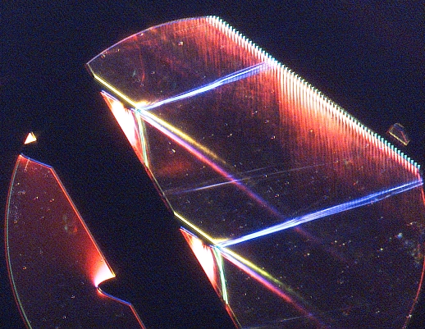

Figure 1: Figure caption is written in Times New Roman 9, bolt and centered. Larger figures may extend over the two columns.

The legend is written in Times New Roman 9, bolt and centered. Put one line spacing after the legend. The legend is written in Times New Roman 9, bolt and centered. Put one line spacing after the legend. The legend is written in Times New Roman 9, bolt and centered. Put one line spacing after the legend.

The text is in Times New Roman 10 aligned on both sides. First line of each paragraph indents .5 cm. Put one line spacing before the subsection. The text is in Times New Roman 10 aligned on both sides. First line of each paragraph indents .5 cm. One line spacing before the subsection. The text is in Times New Roman 10 aligned on both sides. First line of each paragraph indents .5 cm. Put one line spacing before the subsection. The text is in Times New Roman 10 aligned on both sides. First line of each paragraph indents .5 cm. One line spacing before the subsection. The text is in Times New Roman 10 aligned on both sides. First line of each paragraph indents .5 cm. Put one line spacing before the subsection. The text is in Times New Roman 10 aligned on both sides. First line of each paragraph indents .5 cm. One line spacing before the subsection

# Conclusions

The text is in Times New Roman 10 aligned on both sides. First line of each paragraph indents .5 cm. Put one line spacing before the subsection title. No extra line spacing after the section title. Maximum number of pages is ten.

# Acknowledgements

The text is in Times New Roman 10 aligned on both sides. First line of each paragraph indents .5 cm. Put one line spacing before the subsection title. No extra line spacing after the section title.

The format for the references is shown below

# References

1. J. Doe and J. Smith. Title of the paper. *Name of the journal*, Vol.(No.):pp–pp, year.
2. J. Doe and J. Smith. *Title of the book*. publisher, city, year
3. J. Doe and J. Smith. Title of the proceeding’s contribution. In *Title of the proceedings*, pages pp–pp, city, year.